1. *No validation for empty fields Dependants*

*Priority: Medium*

*Steps:*

*1. Open the app → log in*

*2. Click on <add employee>*

*3. Leave empty fields Dependants*

*4. Click the add button*

*Actual result:*

*Clicking the button, do not trigger any action.*

*In DEVTools appers https 405.*

*Expected result:*

*When user click the add button should appears validation message for empty files.*

*User should see the range of possible value (0-32)*

*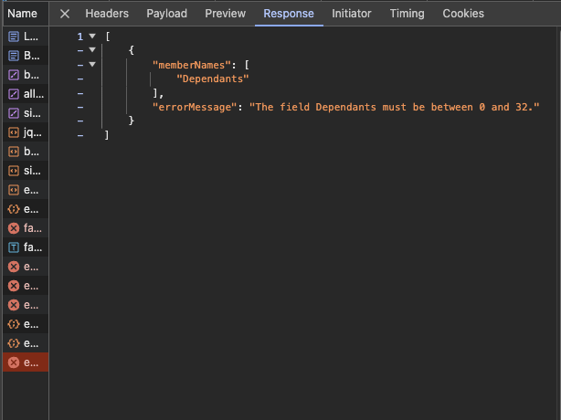*

*2. Favicon is forbidden*

*Priority: Low*

*Browser: Opera*

*Steps:*

*1.Log in do the app*

*Actual results:*

*In devtolls appears:*

*Https 404*

*{message: "Forbidden"}*

*message: "Forbidden"*

*Expected result:*

*Favicona should appears in the browser tab.*

*Expected result:*

*Favicon should be visible/loaded.*

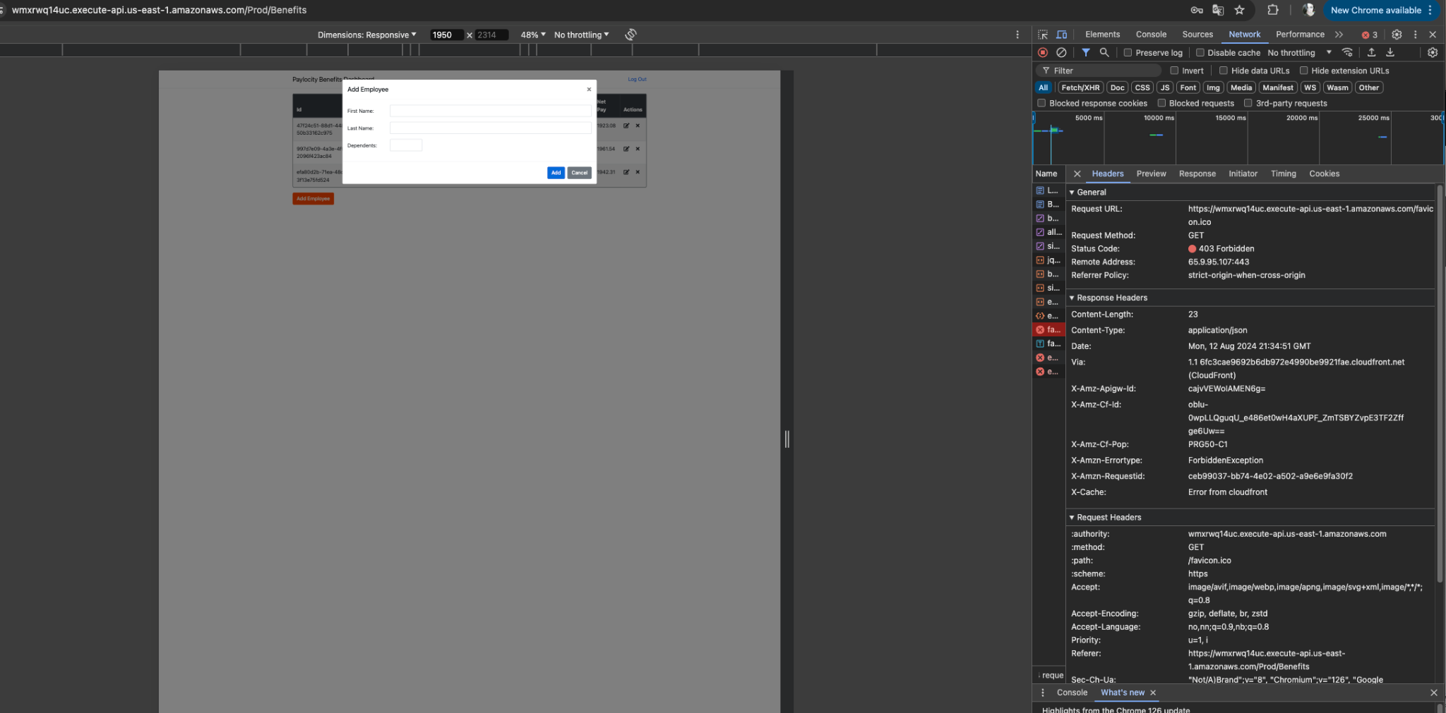

*3. No validation for empty fields First/Last Name*

*Priority: Medium*

*Steps:*

*1. Open the app → log in*

*2. Click on <add employee>*

*3. Leave empty fields First/Last Name*

*4. Click the add button*

*Actual result:*

*Clicking the button, do not trigger any action. In DEVTools appers https 400*

*Expected result:*

*When user click the add button should appears validation message for empty files.*

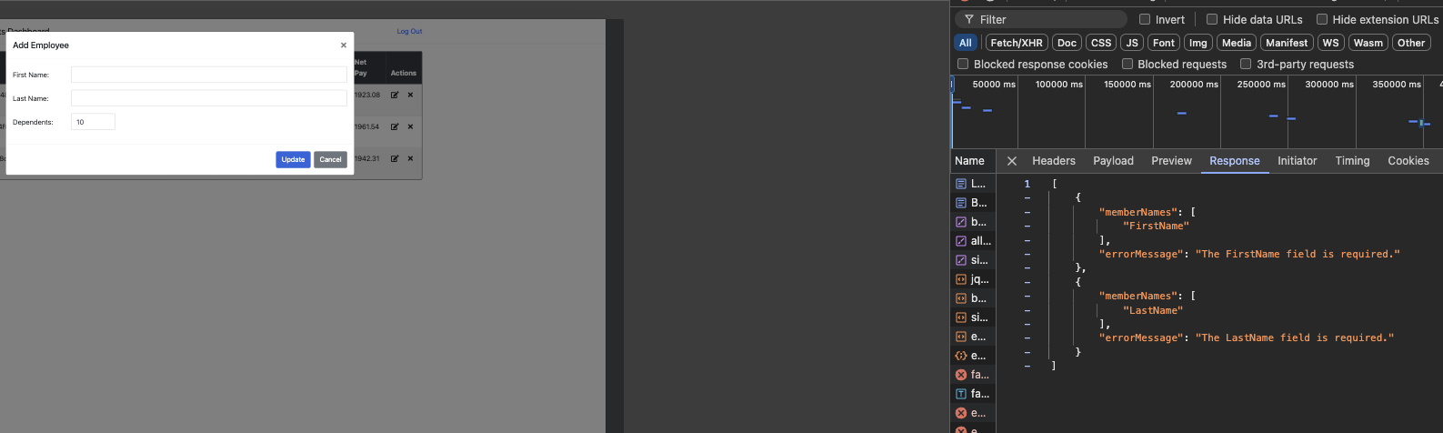

*4. User has an acces to the data when his session is expired*

*Priority: Hight*

*Steps:*

*1. Open the app → Log in*

*2. Do not use app for the longer time*

*2. Click the add employee/ update empoyee/ delete employee*

*Actual result:*

*User has an acces to the dashboard but can not trigger any action on employees data.*

*In devtols get http 401.*

*Expected result:*

*User should be logged out and redirected to the login page, when session was expired*